Instruction Manual
Mass Flow Controller
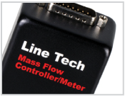
M3700 Series (Analogue)
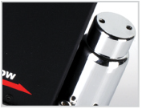
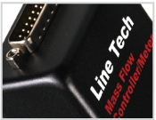
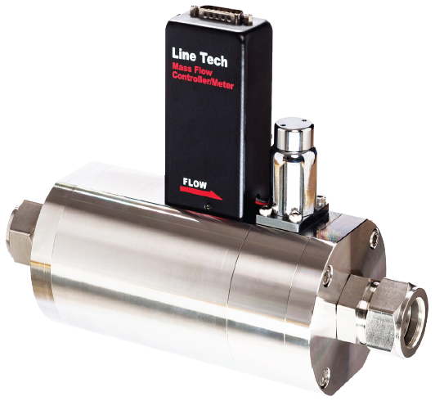
806,

Daedeok-daero, Yuseong-gu, Daejeon Korea
Tel. +82-42-624-0700
Fax. +82-42-638-2211
E-mail : linetech@line-tech.co.kr
Homepage : www.line-tech.co.kr
Table of Contents

INTRODUCTION ······················································································ 1

DESCRIPTION ·························································································· 1

DIMENSION & SPECIFICATION ··························································· 2

FEATURE ··································································································· 3

INSTALLATION ························································································ 3

ELECTRIC CONNECTION (Voltage Type) ············································ 4

ELECTRIC CONNECTION (Current Type) ············································ 5

OPERATION ····························································································· 6

USE OF THE CONVERSION TABLE ······················································ 7

SET POINT STEP AND SOFT START ··················································· 8

RESPONSE TIME ···················································································· 8

Instruction

The M-SERIES of Line Tech Mass Flow Controller (MFC) is a device designed for accurately measuring and controlling flow rates of gases. This manual is intended to provide the user with all the information to install successfully.

Description
The Line Tech of Mass Flow Controller is used widely in the Semiconductor industry as well as many other gas control system.
Mass Flow Controller is classified into three parts. (Body, P.C.B, Control valve)
This harmony produces stable gas flow of rate as well readjusting gas pressure continuously.

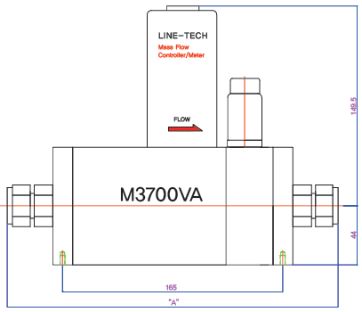
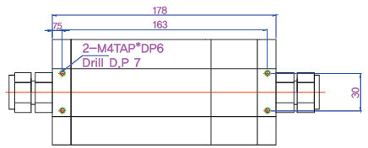
Dimension & Specification (M3700 Series)
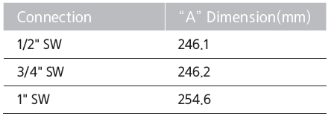

▶Standard Ranges ▶Accuracy
1500 ~ 2000 slpm ±1%
▶Repeatability ▶In/Out Signal
±0.25% 0 ~ 5Vdc or 4 ~ 20㎃
▶Supply Power ▶Max Operating Pressure
+15Vdc or +24Vdc , 350㎃ < 6 barG
▶Max Operating Temperature ▶Leak Rate
0 ~ 50℃ 1×10⁻⁹atm.cc/sec
▶Control Range ▶Electrical Connection
3 ~ 100% 15 Pin D-Connector
▶Response Time
Less than 3 seconds response to within 3% of Full Scale

※ Up to 2000 SLPM is option
Features
▶Accurate at Low Flow ▶Fast response
▶Compact Connection ▶Removable Highly Stable Sensor
▶High Corrosion Resistance ▶Excellent Linearity
▶Excellent Long-Term Stability ▶Modular Design
▶Wide Pressure Range Available

Installation
The M-Series of Line Tech inlet and outlet connection standard is V.C.R and S.W.G type.
Install the equipment with consideration to the given structure and strength condition. Be sure to clean the inside of pipe line by blowing high-pressured gas before connecting to MFC.

※ Cautions When Installing ※
▶Check gas flow direction.
▶When using corrosive or inflammable gas, completely rid the system of moisture or leakage with N2 gas before the usage.
▶Do not install the equipment in the presence of possible mechanical damage or vibration.

Electric Connection - Voltage

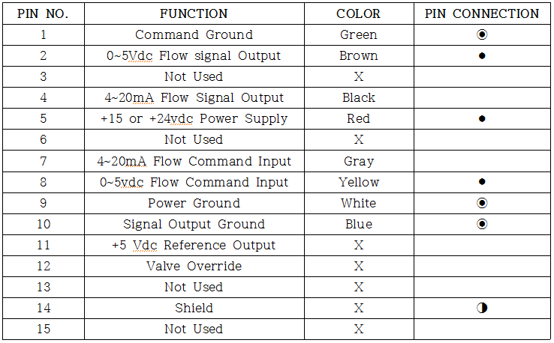

Mass Flow Controller Mass Flow Meter
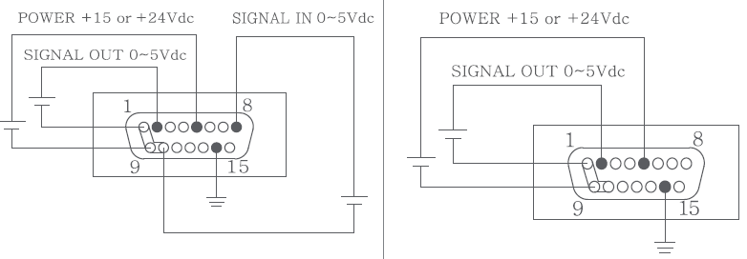

Electric Connection - Current
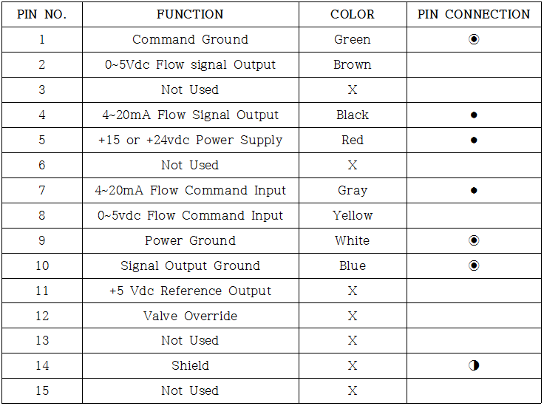

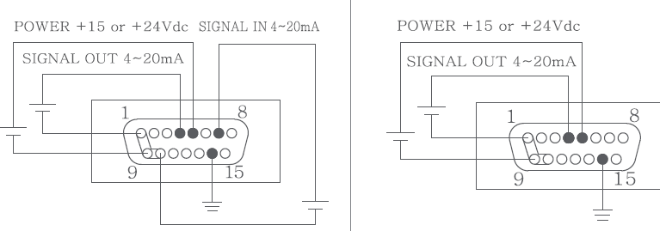
Mass Flow Controller Mass Flow Meter
Operation
◉ Warm up time ◉
1) After installing, warm up equipment for 30 minutes to stabilize the temperature of the sensor.
2) Before supplying gas, adjust the zero point to less than 0.2%
3) Supply gas.
4) Check for any leakage.
5) Operate.

◉ Setting up the Zero Point ◉
▶The Zero Point may change depending on the surrounding's temperature installation structure.
▶Approximately 30 minutes after supplying power, when installed according to the correct environment and application conditions, set up the final Zero Point.

Use of the Conversion Tables

If a mass flow controller is operated on a gas other than the gas it was calibrated with, a scale shift will occur in the relationship between the output signal and the mass flow rate. This is due to the difference in heat capacities between the two gases. This scale shift can be approximated by using the ratio of the molar specific heat of the two gases or sensor conversion factors.
factor of the new gas
Actual gas flow rate = Output reading X
factor of the calibrated gas

ex) The controller is calibrated for nitrogen
The desired gas is Carbon dioxide
The Output reading is 75 sccm when carbon dioxide is flowing
Then 75 X 0.74 = 55.50 sccm
In order to calculate the conversion factor for a gas mixture, the following formula should be used.
Sensor Conversion Factor for Mixture
100
=

P1 + P2 + · · · · + Pn
sensor conversion factor n
sensor conversion factor 2
sensor conversion factor 1

P1 = percentage (%) of gas 1 (by volume)
P2 = percentage (%) of gas 2 (by volume)
Pn = percentage (%) of gas n (by volume)

ex) The desired gas is 20% helium(He) and 80% Chlorine(Cl₂) by volume.
The desired full scale flow rate of mixture is 20 slpm.
Sensor Conversion Factor for Mixture
100
= 0.093
=
0.950
20 + 80
1.39 0.88

Then, air equivalent flow = 20/0.903=22.15 slpm Air

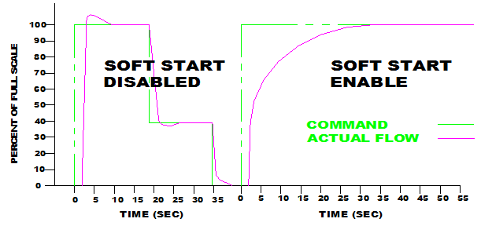
Set point step and soft start

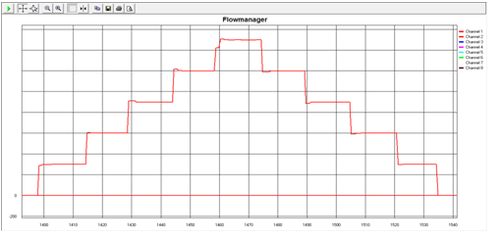
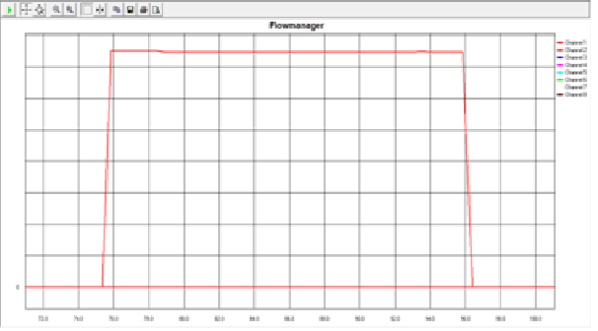
Response Time
<Low to Max to Low> <Step up & down>

